Analysis of the impact of the change in methodology in the SIMD 2012 Income Domain

The SIMD 2012 income domain is a count of the number of people claiming the following benefits:

- Number of Adults (aged 16-59) receiving Income Support or Income-based Employment and Support Allowance
- Number of Adults (aged 60 plus) receiving Guaranteed Pension Credit
- Number of Children (aged 0-15) dependent on a recipient of Income Support, Jobseekers Allowance or Employment and Support Allowance
- Number of Adults receiving (all) Job Seekers Allowance
- Number of Children (aged 0-15) dependent on a recipient of Job Seekers Allowance (all)
- Number of Adults and Children in Tax Credit Families on low incomes
Although there are no overall changes to the indicators included in the income domain between SIMD 2009 and SIMD 2012, the indicators highlighted in red have been affected by changes to the benefits system and a change to the methodology for calculating the low income threshold. This is explained below:

- Claimants who would previously have received Income Support (IS) may now receive Employment and Support Allowance (ESA). Therefore claimants of ESA are now included in the Income domain. This does not however represent any real change to the benefit group being measured as ESA is a new benefit that has replaced IS paid on the grounds of ill-health or disability.
- The methodology used to calculate the low income threshold for the indicator measuring 'Number of Adults and Children in Tax Credit Families on low incomes' has changed to be consistent with the methodology used by HMRC to produce child poverty estimates as it provides a better count of those in poverty. Based on this new methodology, the low income threshold is £198. Under the previous methodology, the low income threshold would have been £250. Due to this change, the absolute counts of income deprived people are not directly comparable between SIMD 2009 and SIMD 2012.
As a result of these changes, the SIMD 2012 income domain results are not directly comparable with previous years.

In order to look at the impact of the change in methodology for calculating the low income threshold, DWP and HMRC provided the Scottish Government with additional data based on a low income threshold of £250 to be in line with the previous methodology used in earlier SIMD updates. Table 1 below includes the official SIMD 2012 income domain results based on the low income threshold of £198 and the results based on the old methodology with a low income threshold of £250.

Table 1: Percentage of people who are income deprived in SIMD 2009, SIMD 2009+1, SIMD 2009+2, SIMD 2012, by Local Authority
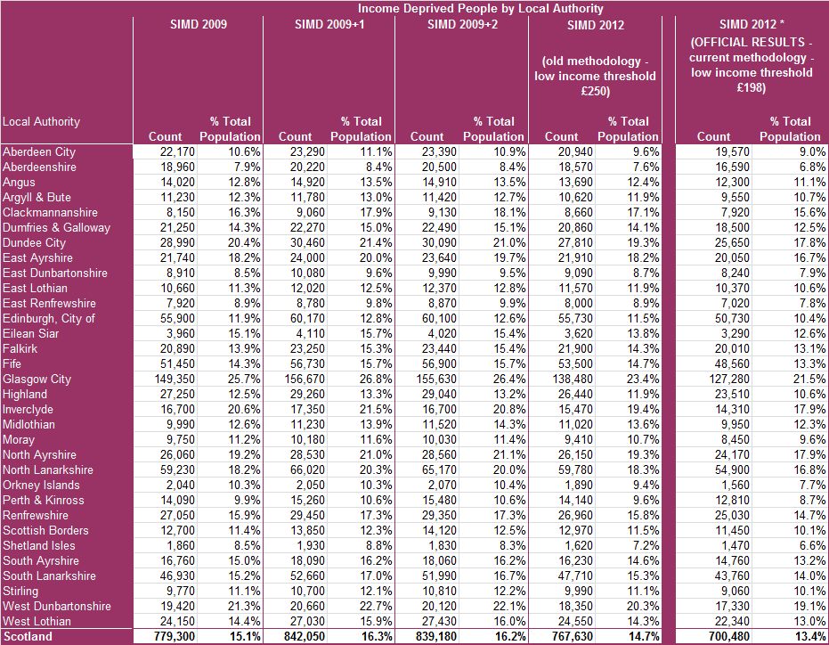
Note: * The SIMD 2012 official results are not directly comparable with previous years due to the change in methodology for calculating the low income threshold associated with the tax credit indicator.

