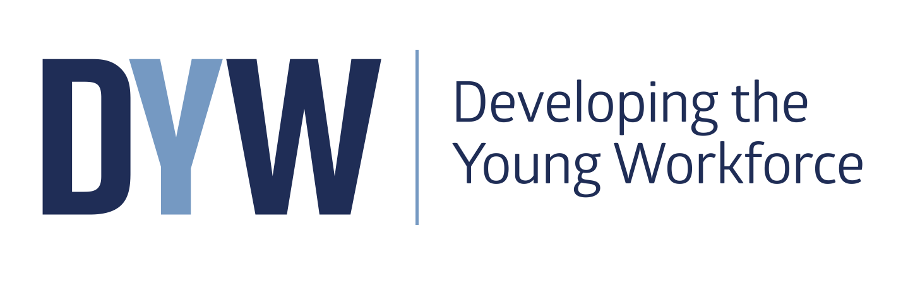

Information update

June 2017

Headline Target – to reduce youth unemployment by 40% from 2014 levels by 2021

Our vision: To develop Scotland’s young workforce by providing young people with learning which is directly relevant to getting a job, benefiting individuals and improving the economy through increased youth employment.

Resources and information

How to engage with Education Scotland and others

Join the professional conversations on Yammer? The ideal place for practitioners and DYW leads to share ideas, resources, approaches and to network and collaborate with other practitioners and co-ordinators.

https://www.yammer.com/glowschools.org.uk/#/threads/inGroup?type=in_group&feedId=8228932&view=all

Sign up for the Developing the Young Workforce (DYW) monthly e-bulletin.

http://www.educationscotland.gov.uk/newsandevents/emailupdates/index.asp

Education Scotland’s learning blog – Keep up to date with news and updates across the organisation.
https://blogs.glowscotland.org.uk/glowblogs/eslb/category/skills/

Follow us on Twitter to get snippets of information @ESskills and use the hashtag #youngworkforce

Email us at edsskills@educationscotland.gsi.gov.uk

DYW Website
The website contains key information including the suite of standards and guidance documents, resource and weblinks as well as news from our blogs and twitter feed.

https://www.education.gov.scot/scottish-education-system/policy-for-scottish-education/policy-drivers/Developing%20the%20Young%20Workforce

More details on the DYW programme and its key components can be found on the Developing Employability, Creativity and Skills web page

https://education.gov.scot/what-we-do/Developing%20employability%20and%20skills

Standards and Guidance documents

Career Education Standard (3-18)
This document contains the entitlements and expectations as well as examples of ‘I can’ statements to support practitioners in developing career education from 3-18.
https://www.education.gov.scot/Documents/dyw2-career-education-standard-0915.pdf

A review of the Career Education Standard, Work Placements Standard and School/Employer Partnership guidance has been undertaken and the report has now been published on the Education Scotland website. (https://education.gov.scot/what-we-do/Developing%20employability%20and%20skills)

Work Placements Standard and benchmarking tool
The standard sets out the expectations for young people, employers, parents, schools and local authorities in advance, during and after a placement. Resources are in development to support schools and Local authorities achieve the ambitions of the standard with the self-evaluation exercise and work placements toolkit already available on our website.

https://www.education.gov.scot/Documents/DYW_WorkPlacementStandard0915.pdf

School/Employer Partnership Guidance - for schools, employers and local authorities
These three documents support the aim of creating meaningful and productive partnerships in all secondary schools, highlighting the benefits and suggest practical steps.

https://www.education.gov.scot/Documents/DYW_GuidanceforSchoolEmployerPartnerships0915.pdf

Interesting practice exemplars

The following interesting practice examples are available on the National Improvement Hub:
- Calderglen HS – Inspirational learning delivered in partnership
- Sanderson High School: Tailored learning pathways to meet the needs of all
- ‘Angus Works’ – Extended work placements for senior phase pupils
- Busby Primary School: Skills development at the core of the curriculum
- Craigroyston Community High School: Developing skills to realise aspirations
- Woodfarm High School: A whole school approach to career education
- Dalziel High School: Skills development through STEM
- Ferguslie – Pre-5 Centre: Skills Development in Early Years
- Skills Academy programme at St Matthew’s Academy (North Ayrshire): Young people gain vital employability and life skills through this unique initiative.
- SCOTS programme at Forth Valley College: Helps learners consider college courses as a progression route in the senior phase.
- Kibble Education and Care Centre: integrated services to equip disadvantaged young people with the skills and experience to pursue a fulfilling career and a brighter future.
- 2+3 pilot project in East Ayrshire: Re-engages learners to industry -focused pathways.
- Developing Career Management Skills – Millburn Area School Group
- Clyde Gateway: Scotland’s most ambitious regeneration project in Glasgow’s East End.
- Pre-Apprenticeship Programme at Govan High School (Glasgow): A highly dynamic partnership programme with a local employer.
- Career education in the primary sector - Caskieberran Primary School: The career education standard has enhance career education across the school and wider cluster.
- ‘Workout’ programme at South Ayrshire Council: A local authority project to deliver sustainable positive destinations for targeted young people in the senior phase.
- ‘Teen Takeover’ and Community Café, Sandwick Junior High School, Shetlands: Two initiatives to enhance the development of skills for learning, life and work.
- Work-based learning initiatives in Dumfries and Galloway: 6 specific work placement opportunities delivered by local employers to support the development of skills.

Capacity building
- The National DYW Leads Network was established in February 2017. It brings together colleagues with a lead role for DYW implementation and delivery from authorities and colleges. The network builds on the initial partnership work done as part of the DYW Learning Events over 2015/16.

- The Professional Learning Reference Group is a key forum to establish a more coherent approach to the planning and delivery of professional learning to support capacity building for Developing the Young Workforce (DYW). The group will focus on the delivery of the milestones set out in Developing the Young Workforce: Scotland’s Youth Employment Strategy for this year 2016/17:
- Employability and enterprise professional standards in development
- Resources available to support school leaders in promoting career pathway planning with opportunities for emerging school leaders to engage directly with industry.

Current organisations represented on this group include:
- General Teaching Council for Scotland (GTCS)
- Skills Development Scotland (SDS)
- Scottish Government - Youth Employment Division (SG)
- Scottish College for Educational Leadership (SCEL)
- Local Authority Representatives
- Young Enterprise Scotland (YES)
- Education Scotland (ES)
- College Development Network (CDH)

The group has had one meeting in Feb 2017

Contact: Mandy Toogood: mandy.toogood@educationscotland.gsi.gov.uk
Mob: 07973381836

- The National STEM Network was launched on 26 January 2017 in Glasgow. The event brought together members from the former sciences, technologies and mathematics networks for the first time to share existing practice in STEM and consider a number of STEM priorities. Over 80 local authority STEM coordinators and officers from most local authorities attended. Education Scotland plan to host further events in 2017.

Contact: Ian Menzies ian.menzies@educationscotland.gsi.gov.uk
Kirsty McFaul Kirsty.mcfaul@educationscotland.gsi.gov.uk
Lorna Walker lorna.walker@educationscotland.gsi.gov.uk

Career Education 3-18

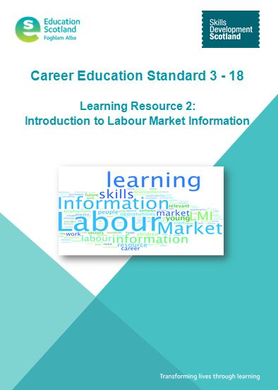
- Professional learning resources available on the National Improvement Hub:
- Learning Resource 1: Introduction to the Career Education Standard (3-18)
- Learning Resource 2: Introduction to the Labour Market Information
- Learning Resource 3: Introduction to the Career Management Skills
- Learning Resource 4: Introduction to My World of Work (to be released March ’17)

This suite of emerging resources are designed to support the expectations for teachers/practitioners set out on page 10 of the Career Education Standard (3-18). We anticipate that these resources – which have been designed to align with GTCS Professional Standards - will also be available via SCEL.

Contact: Klaus.Mayer@educationscotland.gsi.gov.uk

- A suite of teaching resources designed with and for teaching staff to use with students is available at https://www.myworldofwork.co.uk/partners . These resources guide teaching staff on how to get the best out of My World of Work including within their subject area. Each activity is designed to meet a range of experiences and outcomes and support teachers to deliver the entitlements / ‘I can’ statements defined by the Career Education Standard .

- Primary school career education resources – My World of Work/I can.
A suite of tools designed for use by teachers with children in P5 to P7. Mapped to CfE and the Career Education Standard, the three fun and engaging tools help introduce children to the concept of careers and how it relates to them.
More information and how to get started at:
https://www.myworldofwork.co.uk/primary

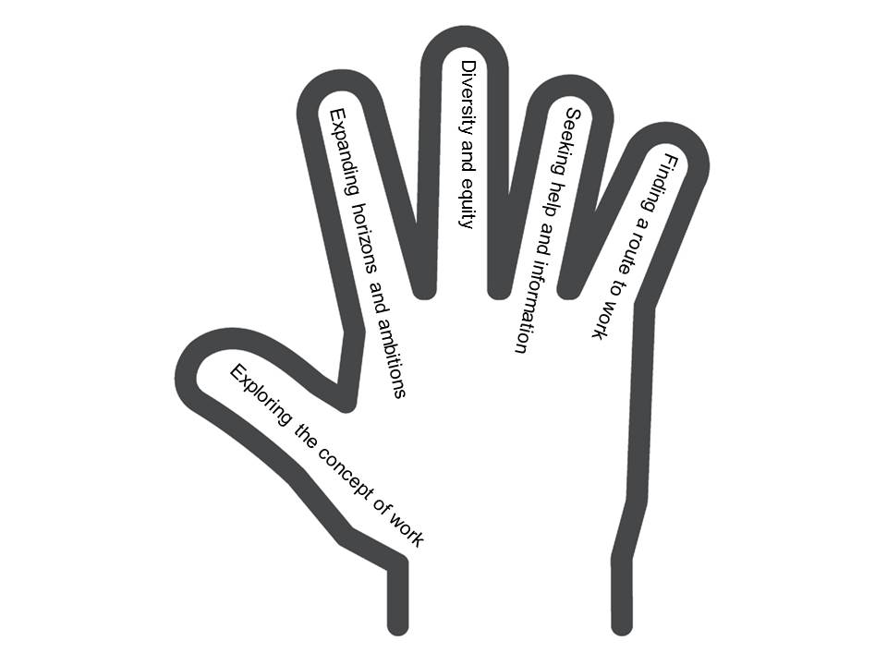
- Career Education Standard – Exemplification tool:
Based on the ‘I can’ statements this tool supports organisations and practitioners in planning, delivery and reflection on the implementation of the standard . https://blogs.glowscotland.org.uk/glowblogs/eslb/2016/12/01/career-education-standard-3-18-exemplification-tool-offers-a-helping-hand/

- Parent resources:

- Career Education: A World of Possibilities http://www.npfs.org.uk/wp-content/uploads/2015/09/NPFS_world_of_possibilities_1509_E.pdf
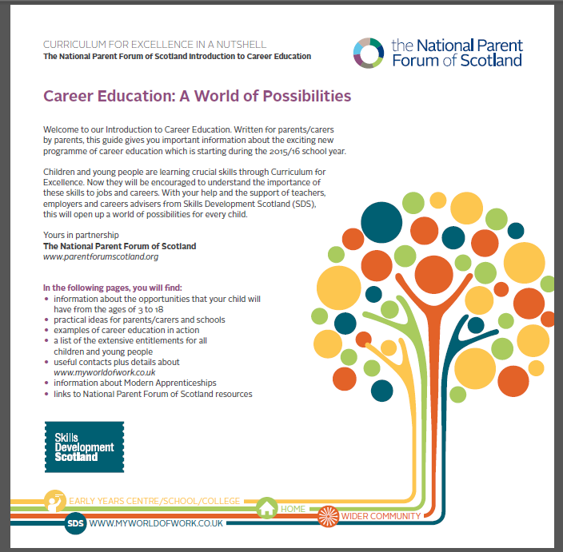
- Skills in a Nutshell http://www.npfs.org.uk/skills-in-a-nutshell/

- Learning Pathways in the Senior Phase and beyond. http://www.npfs.org.uk/wp-content/uploads/2015/06/nutshells_pathway_E.pdf

- Career Conversations in a Nutshell
http://www.npfs.org.uk/wp-content/uploads/2017/02/career_conversations_JAN17_E.pdf

- Digital Skills in a Nutshell
http://www.npfs.org.uk/wp-content/uploads/2017/02/NPFS_digital_careers_E6A.pdf

- Creativity, Enterprise and Employability: Skills for Learning Life and Work
http://www.npfs.org.uk/wp-content/uploads/2017/05/creativity_E.pdf

Coming soon:
- Apprenticeships in a Nutshell

Help and information for parents and carers on how to support their child with career decisions at https://www.myworldofwork.co.uk/parents

- My World of Work
Skills Development Scotland’s (SDS) award-winning careers web service, complements the Career Management Skills Framework and supports the SDS’s work of Careers Advisers in schools, colleges and local centres. Used extensively in secondary schools, the website offers customers careers information and advice on:
  - My Career Options
  - Learn and train
  - Getting a job

Latest tools: https://www.myworldofwork.co.uk/

- My World of Work Ambassadors
The programme is free, easy-to-run, with ready-made resources providing career education benefits for pupils, teachers, parents, carers and the wider school community. The ambition is for every school in Scotland to recruit volunteer Ambassadors who have the aim of spreading the word about the advice, information and resources available on My World of Work and the help it can offer to pupils and their parents, carers and teachers.
Ambassadors gain valuable experience working on promotional activities in school, while building employability and career management skills that can be used in their future education and working lives. Staff will also benefit from experience gained in leadership and project management. A full suite of project resources for pupils and teachers have been designed in a logical, easy to follow format.
More at https://www.myworldofwork.co.uk/partners

- My World of Work Live!

A set of interactive exhibits and activities designed to inspire young people’s interest in careers in science, technology, engineering and maths (STEM). Every free, fun My World of Work Live! experience is about hands-on learning – building, making, designing – and makes the best use of the latest technology to engage and inspire. The My World of Work Live! Digital Studio and Careers Lab at the SDS Inverness careers centre has recently been nominated for a UK Career Development Award for Best Use of Technology in Career Development.
Go to https://www.myworldofwork.co.uk/live to find out more

- Skills Investment plans
Working with employers and industry leadership groups, Skills Development Scotland has produced Skills Investment Plans. The plans focus on key issues for Scotland’s growth industries and provides information about what is being done to help.
https://www.ourskillsforce.co.uk/skills-investment-plans/

STEM
- Raising Aspirations in Science and STEM education (RAISE) Programme
A thirty-three month pilot programme has been launched to raise aspirations in science and STEM education in Scotland’s schools. The £1 million programme is being funded by The Wood Foundation and Scottish Government and led by Education Scotland in partnership with the Scottish Schools Education Research Centre. The RAISE programme, previously entitled the Improving Primary Science Education Programme, will enable ten local authorities to recruit development officers to build the capacity of practitioners in all their schools in relation to learning, teaching and assessment in science and STEM. The programme will have a strong focus on science and STEM in the broad general education and will seek to ensure effective progression in learning across sectors.

From the outset, the programme will seek to make strong connections locally and nationally with other priorities including Developing Scotland’s Young Workforce, the Digital Strategy, he Strategy for STEM Education and Training and Improving Gender Balance in STEM. Also key to the programme will be how it links with our national ambitions to promote excellence and equity within the context of the National Improvement Framework and Scottish Attainment Challenge. Education Scotland and authorities will also be liaising with STEM organisations and providers throughout to promote effective partnership working and explore new models of engagement.

Authorities involved in year 1 (FY 16/17) include: Highland, Moray, East Ayrshire, West Dunbartonshire and Edinburgh. From August 2017, a further five authorities will join the programme including: Fife, Glasgow, Angus, Dumfries and Galloway and Aberdeenshire. All of the authorities involved have an existing commitment to science and STEM and have been involved in the Primary Cluster Programme supported by the Scottish Schools Education Research Centre (SSERC).

Following an externally evaluation there may be the opportunity for the RAISE Programme to be extended to all 32 local authorities over a total of an eight-year period. We would encourage all DYW leads within the pilot authorities to contact their authority leads for the RAISE programme if they haven’t already done so.

Contact: gayle.duffus@educationscotland.gsi.gov.uk . National Education Officer.

- National STEM Network – see note 3.

Learner Journey 15-24/senior phase
- The Learner Journey Review (15-14) is now underway. The 15-24 Learner Journey review is a programme of work, led by the Scottish Government in partnership with others, to review the effectiveness and efficiency of the Learner Journey for all 15 to 24 year olds. There are two drivers for the review: learner personalisation and choice, and system efficiency. The review will consider the 15-24 Learner Journey from the senior phase (S4-S6) leading to employment, including the stages of further and higher education in college, higher education in university, vocational training and apprenticeships.
The review will build on the key SG strategies and policies already in place in relation to the 15-24 learning system: for example, Curriculum for Excellence, Developing Young Workforce, Widening Access, Raising Attainment.
The review is taking place over two stages. Stage 1 runs between September 2016 and September 2017 (with research conducted over Sep 16-Feb 17).

- The new Arrangements for assuring and improving the quality of provision in Scotland’s colleges implemented in December 2016 require colleges to engage local authorities, schools, employers and community partners in evaluating the quality provision and planning for improvement.

Curriculum development work in ES for 2017/18 will build on these arrangements. to support and enable post-compulsory education and training providers to jointly evaluate the regional curriculum offer and plan for improvement. This includes supporting meaningful ‘bridging’ from schools to other post-compulsory education providers and strengthening understanding amongst teachers of the role of individual subject areas within industry sectors. 2 pilots have been identified in Forth Valley and Fife. Work has started to engage DYW leads in schools/authorities and colleges in joint evaluative activities.

- Senior Phase Service Design Group.
In April 2016 a group of 30 partners representing schools, local authorities, colleges, business/industry sectors, parents, third sector and national organisations held a senior phase design workshop facilitated by SNOOK. The outputs from the workshop will form part of the wider body of tools to support senior phase planning and design. The group will continue to meet over 2017/18 to develop thinking and tools.

18. Senior Phase Benchmarking Tool
This tool has been developed to help organisations evaluate current approaches to planning the senior phase of the curriculum and to consider any necessary improvements/actions.
https://education.gov.scot/improvement/Pages/dyw5-senior-phase-benchmark-tool.aspx

19. Work Placements Standard Tool kits:
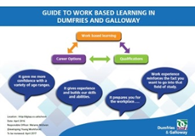
- Work Placements Standard Benchmarking tool
https://education.gov.scot/improvement/Pages/dyw4-work-placements-standard-benchmarking-exercise.aspx

- Kibble Education and Care Centre
http://www.kibble.org/assets/0000/2538/kibble-young-workforce-development-toolkit.pdf

- Guide to work-based learning in Dumfries and Galloway
https://education.gov.scot/improvement/Pages/dyw13-work-placement-opportunities.aspx

20. Self-evaluation guide for school/college partnerships
This self-evaluation guide has been created for school and college senior managers, practitioners, guidance and support staff to assist quality enhancement as part of the ongoing analysis of partnerships between schools and colleges.
https://education.gov.scot/improvement/Pages/frwk9-school-college-partnerships.aspx

Apprenticeships

21. Foundation Apprenticeships allow young people to complete elements of an apprenticeship while still at school. Available in 2017-18 across 10 subject areas:
- Business skills
- Civil engineering
- Creative and Digital Media
- Engineering
- Financial Services
- Hardware and System support
- Scientific Technologies
- Social Services – Children and Young People
- Social services and Healthcare
- Software Development

You can visit apprenticeships.scot/foundation for details of what’s available to students locally and how to register.

22. Graduate Level Apprenticeships provide work-based learning opportunities for employees up to Masters level. Visit apprenticeships.scot for more information.

23. Aspiring apprentices can search for vacancies at apprenticeships.scot. There’s also information for employers on how to get involved as well as a vacancy upload service.

24. Scottish Apprenticeship Week: An annual celebration of the benefits that apprenticeships bring to individuals, businesses and the economy. Taking place from 6-10 March 2017. Find out how to get involved at https://www.apprenticeships.scot/scottish-apprenticeship-week. Follow the action at #ScotAppWeek17

Creativity
25. What Are Creativity Skills?
Infographic outlining the four creativity skills.
https://education.gov.scot/improvement/Pages/cre1whatarecreativityskills.aspx

26. Find your local Creative Learning Network
Local authority contacts leading funded programmes of activity to build capacity for creativity through partnership working.
http://creativityportal.org.uk/?q=&c=,creative-learning-contacts

27. Creativity Infographics
A suite of eight infographics which explain why creativity is integral to Curriculum for Excellence and improves outcomes for all learners. The largest will soon be available as pull up banners in each local authority; all are either printable or look great on a smart phone.
https://education.gov.scot/improvement/Pages/cre24_creativityinfographics.aspx

28. Planning For And Evaluating Creativity
Tools to support planning and that allow evaluation of the development of creativity skills, many of which are used extensively in the field by the Creative Learning Networks
https://education.gov.scot/improvement/Pages/cre23planningforandevaluatingcreativity.aspx

29. Creativity portal
All DYW related items can be found under the following oink:
http://creativityportal.org.uk/?q=&t=,developing-the-young-workforce

Contact: Julia Fenby Julia.fenby@educationscotland.gov.uk
Stephen Bullock Stephen.bullock@educationscotland.gov.uk

Equalities
30. The Improving Gender Balance (IGB) in STEM Programme, now in its second year, is being supported through a partnership between Education Scotland, SDS and the Institute of Physics. In its initial phase the two IGB Project Officers have worked with six school clusters in West Lothian, Fife, Glasgow, South Ayrshire and North Ayrshire to trial whole school approaches to promoting gender balance in STEM.

A suite of resources has now been produced and is available to download from Education Scotland’s National Improvement Hub: https://education.gov.scot/improvement/Pages/sci38-improving-gender-balance.aspx

The third year of the project will see learning from the initial pilot activity being disseminated widely across Scotland.

Contact Charlotte Govan [charlotte.govan@iop.org] or Heather Earnshaw [heather.earnshaw@iop.org]

DYW Regional Groups

31. DYW Regional Groups have been established in 18 regions: Glasgow; North East; Fife; Ayrshire; North Highland; the West Region; Edinburgh, Midlothian and East Lothian; Dumfries and Galloway; Dundee and Angus; West Lothian; Inverness and Central Highland; West Highland; Forth Valley; Moray; Perth & Kinross; Lanarkshire and East Dunbartonshire; Argyll and Bute; and the Borders.
The remaining areas of Western Isles, Orkney and Shetland will be launched June 2017
For the latest information on DYW Regional Groups further information can be found here:
http://www.employabilityinscotland.com/developing-young-workforce

32. DYW Marketplace System is a digital matching platform that will allow employers to post offers of careers, skills and inspiration sessions to schools. The system has been developed as a partnership between Edinburgh, East and Mid Lothian DYW group and Skills Development Scotland, providing the digital expertise to build and host the platform.

- The Marketplace system builds on and is accessed through existing SDS digital platforms Teachers access the system through My World of Work and employers access the system through the Our Skills Force website using existing log-ins.
- A pilot has been successfully completed by the Edinburgh, East and Mid Lothian Developing the Young Workforce group. Marketplace is currently being rolled out to other DYW groups across Scotland . Currently DYW Glasgow, DYW North East and DYW Ayrshire are piloting the system.
- For teachers: Teachers can search for opportunities listed by employers or use Founders 4 Schools to find and invite business leaders to an event at https://www.myworldofwork.co.uk/marketplace
- For employers: Employers can share the opportunity they’d like to offer through https://www.ourskillsforce.co.uk/marketplace

Contact: Sarah.Griffiths@gov.scot

Inspection and review

33. Focus on DYW and implementation of CES 3-18 and the WPS in early years, primary and secondary general inspections from August 2016. There is a specific focus on the Learning pathways theme from 2.2 Curriculum in secondary inspections.
- The new full establishment inspection model has a focus on the theme of Learning Pathways from quality indicator 2.2 Curriculum in How Good is Our School (fourth edition). https://education.gov.scot/improvement/Documents/Frameworks_SelfEvaluation/FRWK2_NIHeditHGIOS/FRWK2_HGIOS4.pdf
- This is providing evidence of the progress schools are making in providing flexible learning pathways for young people to meet a range of different needs and aspirations. It also evaluates the breadth of opportunities on offer including work-based learning and vocational qualifications.
- Within Leadership of Change (quality indicator 1.3), inspectors gather evidence on how well schools work with partners such as colleges, employers and third sector organisations to plan learning pathways and how well the Career Education Standard (3-18) and the Work Placements Standard are being implemented.

34. New College arrangements in place from January 2017 - see item 14.

- How good is our College?
https://education.gov.scot/improvement/Pages/frwk18-hgiocollege.aspx

- Arrangements for assuring and improving the quality of provision and services in Scotland’s colleges December 2016
https://education.gov.scot/improvement/Documents/frwk18-arrangements-scotlands-colleges161216.pdf

35. Career Information and Guidance reviews published since August 2016:

- Highland Council: https://www.education.gov.scot/assets/contactorganisationinspectionreports/ciaghighland111216.pdf

- Renfrewshire Council: https://www.education.gov.scot/assets/contactorganisationinspectionreports/ciagrenfrewshire091216.pdf

- North Lanarkshire Council follow-up review: https://www.education.gov.scot/assets/contactorganisationinspectionreports/ciagnorthlanfollow251116.pdf

36. The Review of the Career Education and Work Placements Standards and the Guidance on School/Employer Partnerships is just finishing. The review looked at the pace of implementation and whether the expectations set out in the standards were ambitious enough. Evidence was gathered from ongoing CIAG and general inspection activity and from: visits to 27 secondary schools and 3 ASN schools across 13 authorities; 72 HT responses via the annual SDS survey; just under 500 responses to an Education Scotland survey and responses from 46 employers via the FSB and CBI. The report has been published in May 2017.

Contact: Peter.connelly@educationscotland.gsi.gov.uk

Scottish Attainment Challenge
37. The Scottish Attainment Challenge (SAC)is about achieving equity in educational outcomes, with a particular focus on closing the poverty-related attainment gap. In order to achieve this goal a team of Attainment Advisors support schools and local authorities to focus on and accelerate targeted improvement activity particularly in literacy, numeracy and health and wellbeing.
More information is available on Education Scotland’s website: https://education.gov.scot/what-we-do/delivering-the-scottish-attainment-challenge/About%20the%20Scottish%20Attainment%20Challenge

38. In support of the SAC The Interventions for Equity Framework is now available. This initial framework is based on a range of interventions and approaches that are currently being used in schools across Scotland and will continue to be updated and developed. These are neither exhaustive or definitive but can provide a helpful stimulus for discussions around planning. Decisions schools make about the most appropriate interventions and approaches should be based on effective self-evaluation and improvement planning, including robust measures of impact and progress.
The framework can be accessed on the National Improvement Hub (https://education.gov.scot/improvement/framework-for-intervention )

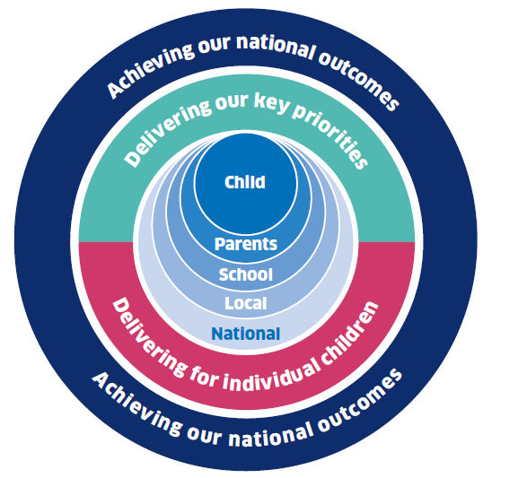
National Improvement Framework
39. The National Improvement Framework (NIF)is one of the key policy initiatives in Scottish Education designed to accelerate progress in improving outcomes for young people in four key priority areas.:
•Improvement in attainment, particularly in literacy and numeracy;
• Closing the attainment gap between the most and least disadvantaged children;
• Improvement in children and young people’s health and wellbeing; and
• Improvement in employability skills and sustained, positive school leaver destinations for all young people;

The actions set out in the National Improvement Framework for Scottish Education (January 2016) have all been developed to support high-quality learning, teaching and assessment, the core principle of Curriculum for Excellence. It identifies 6 key drivers of improvement:
•School leadership
•Teacher professionalism
•Parental engagement
•Assessment of children’s progress
•School improvement
•Performance information

Over time, the Framework will provide a level of robust, consistent and transparent data across Scotland that we have never had before, to extend our understanding of what works and to drive improvements across all parts of the system.
More information can be accessed on the National Improvement Hub: https://education.gov.scot/improvement/Pages/nifnationalimprovementframework.aspx

Other useful resources and websites
SFC Early Adopter Programme Evaluation Report
Evaluation report on Scottish Funding Council’s Early Adopter Programme to guide regional partnerships in the development of senior phase vocational pathways.
http://www.sfc.ac.uk/web/FILES/Corporate_publications_Evaluation_report_for_the_SFC_Early_Adopter_Programme_SFC/SFCCP042016_Evaluation_report_for_the_SFC_Early_Adopter_Programme.pdf

DYW and Insight
An article outlining how the Insight benchmarking tool supports DYW.

https://blogs.glowscotland.org.uk/glowblogs/eslb/2016/09/06/in-focus-how-insight-supports-dyw/

Colleges Scotland Learner Journey Think Piece

http://collegesscotland.ac.uk/briefings-and-publications/851-think-piece-the-learning-and-skills-journey/file

DYW 2nd Annual Report 2015/16
The second Developing the Young Workforce annual report has been published, setting out last year’s progress of implementing the seven year programme.

http://www.gov.scot/Publications/2016/12/2989

SQA: http://www.sqa.org.uk/sqa/71723.html

Investors in Young People
http://investorsinpeople.scot/investors-in-young-people/

Foundation Apprenticeships
https://www.apprenticeships.scot/foundation-apprenticeships/

Scottish Credit and Qualifications Framework
http://scqf.org.uk/

Equate Scotland
http://www.equatescotland.org.uk/

Princes Trust
https://www.princes-trust.org.uk/

Young Enterprise Scotland
http://www.yes.org.uk/

Scotland’s Enterprising Schools
http://enterprisingschools.scot/

Springboard:
http://springboard.uk.net/events/2-uncategorised/21-springboard-scotland

Review of Youth Awards in Scotland
The review considered how well youth awards in Scotland collectively contribute to:
• improved life chances for young people
• stronger, more resilient, supportive, influential and inclusive communities
• and the implementation of Curriculum for Excellence

http://www.educationscotland.gov.uk/resources/r/genericresource_tcm4871965.asp

Looking at Gender Balance in STEM Subjects
Find useful resources to promote gender equality in STEM as well as key research findings and influencing factors.

https://education.gov.scot/improvement/Pages/sci15genderbalanceinstem.aspx

Preparing Young People for the Future – Senior phase in Scotland’s colleges
The report seeks to provide direction and support to colleges and their partners involved in delivering the senior phase of CfE, and implementation of the recommendations of Developing the Young Workforce (DYW).

