

Personal outcomes, person-centred working and personalisation
Thinking about different approaches in health and social care in Scotland
December 2018


Contents

Executive summary 2
About this review 4
Narrowing the scope of our review 5
Conducting the review 6
The historical backdrop 7
The emergence of person-centred working in social care 8
The emergence of person-centred care in health 8
Person-centred working and the influence of service user movements 10
Summary learning from this review 12
The question of definition 12
Relationship-based understandings of person-centred approaches 13
Beyond definition: embedding person-centred working in policy and practice 13
Consensus points 14
Points of difference 15
Conclusion 17
Acknowledgement 18

Executive summary

This review presents initial reflections following a review of approaches and policies around personal outcomes, person-centred working and personalisation across health, social care and wider public services in Scotland. Many practitioners say they feel overwhelmed by the range of initiatives being implemented, which prompted this exploration of similarities and differences between them. Our aim is to reduce confusion and progress person-centred ways of working to improve outcomes for people, tackle inequalities and support the sustainability of services. To make the review manageable we had to be selective so we included the following approaches:
- shared decision making (in clinical situations)
- support for self-management
- anticipatory care planning
- personal outcomes approaches
- personalisation through self-directed support
- person-centred care for older people with dementia
- person-centred planning with people with learning disabilities
- facilitating recovery by people living with mental illness.
A key finding of the review is that apparent distinctions between sectors and approaches are less prevalent than divergences within approaches. Two main ideological thrusts influence approaches to implementation. These can at times contradict each other and present barriers to achieving core shared principles.
- Actions reflecting consumerist ideology, concerned largely with individual choice and independence. This tends to be associated with managerial and bureaucratic ways of working
- Actions reflecting participatory democracy, concerned with responsive and inclusive ways of meeting people’s outcomes individually and collectively. The emphasis is on relational practice and interdependence
All approaches use language claiming to put the person at the centre. There is however an implicit assumption in managerialist thinking that you can tackle improved outcomes and inequalities through standardisation of provision and its measurement through performance management regimes.
In contrast, a relationship based understanding means engaging with the person in the context of material and lived experiences, which might mean departing from a sole focus on clinical treatments and traditional services. Attending to the person’s whole life requires an understanding of the social determinants known to correspond closely to persistent health inequalities. Similarities between approaches lean towards the latter principles, whereby there is recognition of the need to:
- engage with the person / family in the context of their whole life
- engage in knowledge exchange, rather than professionals imparting knowledge
- acknowledge and build on people’s strengths and capacities
- build connections to community and not just services.
Key differences between approaches centre on:
- ideas about what constitutes effective engagement
- ideas about the extent to which and how personally valued outcomes or goals should influence decision making
- the extent to which agreed outcomes are recorded in plans which are then stuck to
- whether families and other carers are included in planning and decision making.
There remains a need to measure, monitor and track outputs and outcomes in order to plan and manage services effectively. However, there are limitations to what is currently measured, and as a result what is deemed to count. All of the approaches we reviewed advocate the essential relational and holistic practices needed to maximise outcomes for people and address persistent and increasing inequalities at some level. Enabling such practices to flourish requires a re-orientation of performance management frameworks to include relational and holistic factors.

About this review
This review presents initial thoughts on related approaches and polices around personal outcomes, person-centred working and personalisation across health, social care and wider public services in Scotland. Many practitioners said they were feeling overwhelmed by the range of initiatives currently being implemented and it seemed worth exploring distinctions and similarities between them. Our aim was to reduce confusion and progress person-centred ways of working to improve outcomes for people, tackle inequalities and support the sustainability of services. Our review was commissioned as one of four resources to support workers and organisations to develop and embed personal outcomes approaches in practice. The others are:
- Personal Outcomes Collaboration website:
http://personaloutcomescollaboration.org
- Understanding personal outcomes booklet http://learn.sssc.uk.com/personal_outcomes/Personal_Outcomes_booklet_p2_FV_GM.pdf
- Personal Outcomes Planning ibook http://learn.sssc.uk.com/popr
Our review complements the Personal Outcomes and Person-centred Approaches (POPA) graphic, which visually contextualises drivers and initiatives around ‘putting people at the centre’ since the 1950s. An extract is shown below.

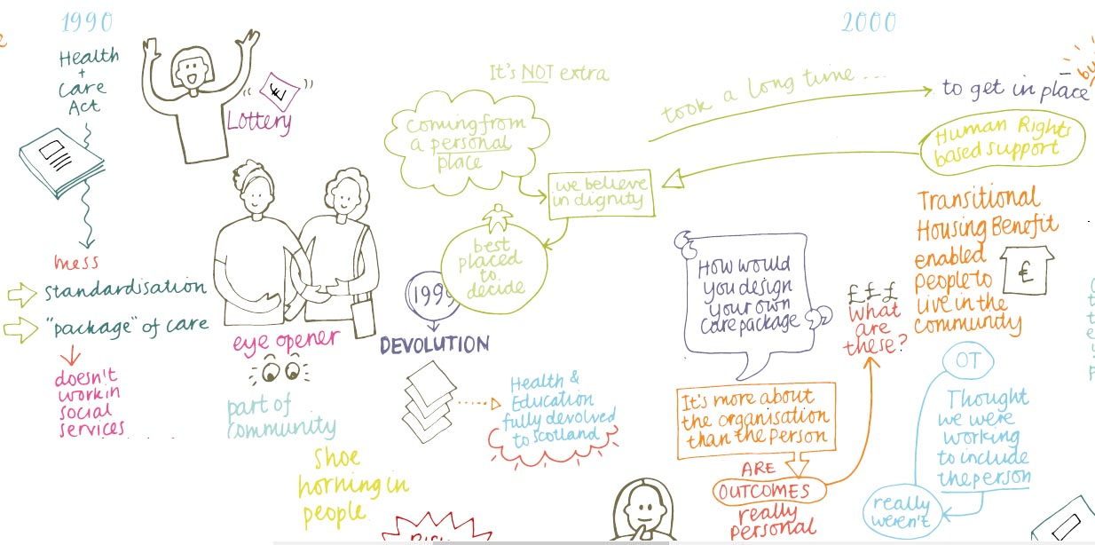

Narrowing the scope of our review
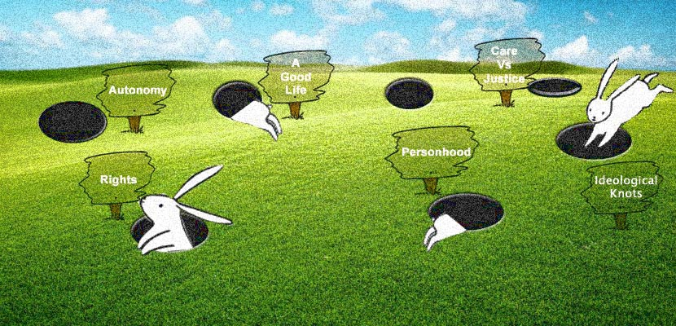
As the POPA graphic illustrates, the journey towards person-centred working is long and ongoing. There have been many significant and interrelated developments along the way. Disentangling the connections between the various initiatives and events that have shaped current approaches is not straightforward.

The approaches are also concerned with philosophical questions such as what it is to be a person and to live a good life. The review had the potential to be very complex so we adopted the phrase ‘watch out for the rabbit holes’. While we did look at wide ranging literature, we had to keep focused on key similarities and differences between a limited range of approaches to make sure it remained manageable.
The review was necessarily selective in the range of initiatives we looked at. It included approaches to and understandings of person-centred care in health policy and the priority areas of:
- shared decision making (in clinical situations)
- support for self-management
- anticipatory care planning.
It also included approaches to and understandings of personalisation in social care policy, notably:
- personal outcomes approaches
- personalisation through self-directed support.
The review also drew on approaches and understandings that have been developed (to varying degrees) for, with and by specific service user groups, illustrated through:
- person-centred care for older people with dementia
- person-centred planning with people with learning disabilities
- facilitating recovery by people living with mental illness.

Conducting the review
Our suite of resources was developed through engagement, involvement and co-design with a wide variety of stakeholders including individuals, carers and the voluntary, independent and public sector workforce. Our review also examined academic, policy and practice literature about each of the approaches, with a focus on more recent developments in Scotland, particularly after devolution. Our review considered the development of each approach in the once largely separate spheres of health and social care. The intention was to understand the importance of context and history, as well as to consider changes over time. The review also looked for patterns across the approaches.
For each approach the review considered:
- the origins of the approach and the particular issues it was developed in response to
- different (and at times conflicting) definitions
- core values and principles for practice and service delivery
- key historical developments
- how the approach has been put into practice
- policy uptake and implementation, including key technologies
- internal tensions

- any distinctive features.
This resource first considers some of the implications of the key historical driving forces illustrated within the POPA graphic, followed by a summary of the learning from the review. The intention is to produce further outputs from the fuller review in future.

The historical backdrop
Person-centred working, personalisation and personal outcomes approaches have developed alongside thinking about the involvement of individuals in their own care and support more generally and also collectively. Throughout the journey towards putting people at the centre, there have been two main drivers which can at times contradict each other.
- Actions which reflect consumerist ideology, concerned largely with developing services and systems that are more responsive to individual preferences, offering a range of service choices in the context of market development and ensuring satisfaction with service delivery. The concept of choice and control encapsulates the emphasis on the autonomous consumer.
- Actions which reflect participatory democracy; concerned with the development of more responsive and inclusive ways of meeting the needs and supporting the aspirations of people who use services individually and collectively, more democratic decision making and concerning people’s lives and society as a whole. The emphasis is on relational ways of working and notions of interdependence rather than independence.
Both consumerist and democratic approaches emerged in the context of struggles and campaigns to gain a voice for ‘service users’ in the face of ‘depersonalised’ care and support – in both the de-individualising and de-humanising senses of the word.
The historical timeline is characterised by an increase in long-term conditions and people living for longer, often with multiple conditions and complex needs that require better coordination of services and supports. This brings a different connotation to the term person-centred. While implementation of the ideas embedded in the concept of person-centred working inevitably influence the way that services should be designed, a service orientation runs the risk of becoming decoupled from what matters to the person in a whole life context.
The increased focus on the individual also reflects wider trends in health and social care services. This includes increased emphasis on independence, autonomy, individual rights and responsibilities, which many activists have called for, but accompanied by a corresponding reduction in collective responsibilities for welfare provision by the state. At the same time there is increased emphasis on accountability, managerialism and performance management. These emphases have intensified in a climate of austerity. As the enabling and preventive potential of person-centred working has been highlighted, it has rapidly been positioned in policy as a cost-effective mechanism for helping society to meet the needs of an ageing population and growing number of people living with long-term conditions, and in ways that pay attention to persistent health inequalities.
Against this backdrop, different person-centred approaches have developed across diverse service settings and over time. At first approaches reflected fundamental concerns with developing different types of relationships and ways of working together to support the things that people value when using services and in the broader contexts of their lives. In different ways however, they have become deeply entangled with concerns about consumer choice, (clinical) effectiveness, improving and managing health, reducing current and offsetting future demand for services and alleviating public spending pressures. We consider the different legacies and entanglements later. We first consider the emergence of person-centred ways of working in social care, and in health. We then consider the role of service user movements and the third sector before going on to outline summary learning from the review.
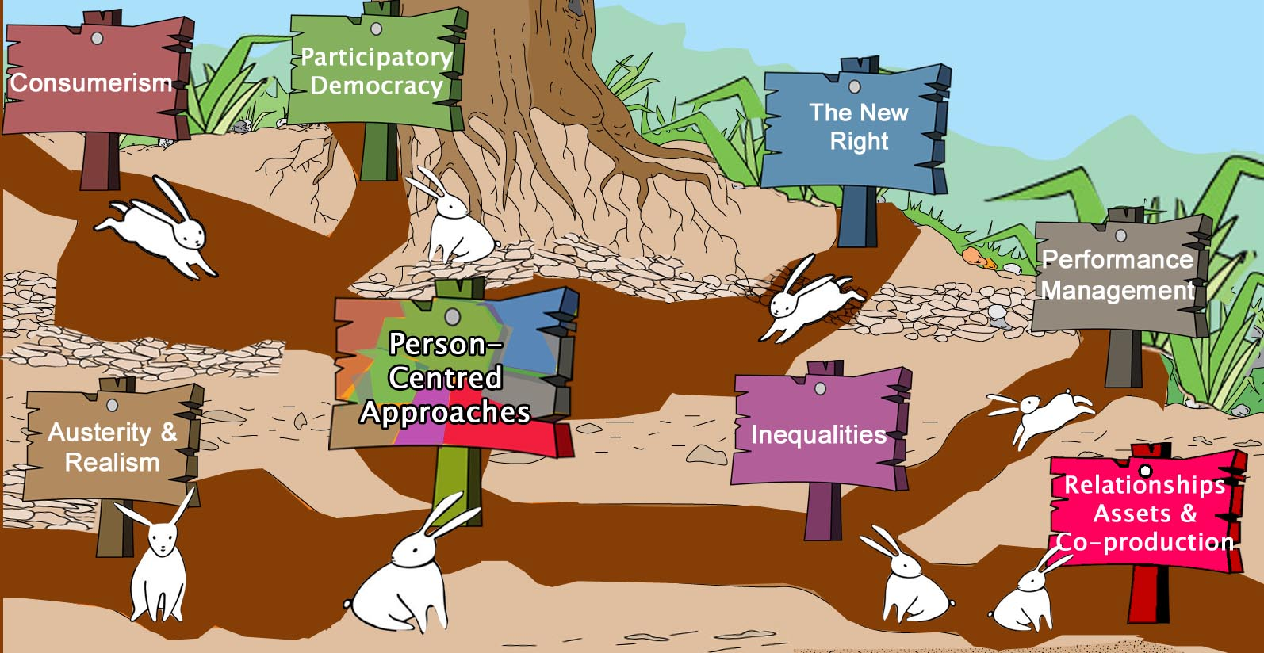

The emergence of person-centred working in social care
In broad terms person-centred working emerged in social care as a response to:
- the assumption that the needs of any particular service user group could be universally defined
- resource and service delivery systems basing provision around the perceived needs of many
- organisations taking decisions for people about the nature of the support they received (and how they should live their lives) and expecting people to fit into one-size-fits-all services
- a focus on people’s deficits
- the risk of creating dependency on services
- quality of care and support being assessed on the basis of activity and throughput.

The emergence of person-centred care in health
In health, the overarching notion of person-centred care emerged as a response to issues including:
- healthcare being too disease-centred (taking a limiting biomedical approach, focusing narrowly on pathologies and applying disease-standardised interventions)
- paternalism – the belief that the clinician knows what’s best for the patient
- naturalisation and normalisation of medical intervention in processes of death, dying, ageing and illness resulting in unwanted and potentially harmful procedures and treatments, particularly in crisis situations, and the risk of confusing care with treatment
- an inappropriate orientation to serve professional or supply-driven interests
- traditional models of service delivery basing provision around the perceived needs of many
- system failures to protect the dignity and respect the personhood of people receiving care
- quality of care being assessed primarily in terms of clinical effectiveness and patient safety, and also in terms of efficiency, timeliness and equity of provision, neglecting patient values.

In response to these issues person-centred working in both health and social care can be variously understood as being concerned with:
- treating people with respect and dignity and relating to them as persons
- responding to and acting on the particular needs, priorities, aspirations and strengths of individuals
- offering a range of service choices that are more responsive to people’s preferences
- sharing decision making or responsibility between professionals and people using services
- shifting responsibility onto people using services and unpaid carers.
Also the following features relate to person-centred working in social care:
- facilitating independent living (or freedom from dependency on the state)
- ensuring that organisations focus resources on the impact they have on people’s lives.

And person-centred working in health can also reflect concerns with:
- restoring humanity in care
- attending to the biological, psychological and social particularities of the individual when making decisions about treatments and interventions
- fully taking account of subjective, lived experiences of illness
- finding more personalised ways to improve health status (and offset future demand)
- tailoring approaches to open up difficult conversations about the limits of healthcare, avoiding unwanted interventions (and reducing future demand)
- expanding quality considerations to encompass ‘putting patients (or persons) at the centre’.

Person-centred working and the influence of service user movements
Service user movements have had a significant impact on the development of person-centred approaches. Some third sector organisations, particularly those who have kept a campaigning orientation have played a supportive role. Some service user movements, particularly in health, have been policy driven and concerned largely (although not exclusively) with enhancing service provision. For advocacy-led or self-initiated service user movements, activism has generally been understood as part of a wider political project rather than narrowly focused on service delivery.
Advocacy-led movements have exerted significant influence in the areas of dementia care and learning difficulties, supported by academic researchers. Person-centred dementia care challenged the ultimate act of exclusion by forcing us to think again about what it means to be a person, underscoring the importance of relationships and highlighting the impact of every interaction and the whole practice of care in sustaining people’s sense of self-worth. Person-centred planning with people with learning disabilities again emphasised relationships. It has proved instrumental in shifting attention from deficits to possibilities, to expand horizons beyond services to connect with people’s future lives, underscoring the need for welcoming communities.
Self-initiated service user movements are most developed in areas of physical disability and mental health, sharing a history of experiences of segregation, isolation and exclusion. Experiences of services have often been oppressive and demeaning, with professionals having the power to ascribe damaged identities and in mental health to mandate compulsory treatments as well as to limit treatment choices. Challenge to the professional dominance and bureaucracy of services was seen as necessary to enable people to gain control over their lives.
The experience of living with disability or mental illness was (and often is) one of discrimination, resulting in a desire to seek change in social relations more broadly so that real progress can be made towards equality and justice. These struggles were rooted in the idea that society has to collectively enable all citizens to take part and to be able to achieve their personal outcomes regardless of impairment (social model) rather than being excluded on the basis of disability or illness with a limited focus on treatment (medical model). Another aim has been to improve public services but also to change public perceptions and everyday life experiences. These aspirations are embedded in person-centred approaches in these fields, which additionally reflect concerns with:

- countering the risk of casual disregard for people’s humanity behind institutional doors
- offering or restoring hope for the future
- empowerment and self-determination
- challenging discrimination in specialist and mainstream service settings and in wider society
- supporting people to overcome barriers to inclusion and participation in social life.
When viewed through different lenses, the different dimensions of person-centred approaches are not necessarily incompatible with one another but they can be. Disentangling the connections is not straightforward.

Summary learning from this review
The review set out to explore and clarify similarities and differences between related approaches around personal outcomes, person-centred working and personalisation across health and social care services in Scotland. When conducting the review, it quickly became apparent that there were many different and at times competing definitions, understandings and uses within each approach, which both complicated and changed the nature of the review.

The question of definition

There are many different definitions for each of the selected approaches and they are open to different interpretations in and across policy and practice. It is not simply that the definitions differ in content, but they can refer to:
- an experience – what the person using the service experiences subjectively
- a philosophy or set of values
- an approach that guides practice
- a service orientation
- a dimension of care quality.
In turn the concepts that these definitions refer to, sometimes implicitly, can also be subject to diverse understandings. There may be consensus that a given approach is a good idea but it is not good for everybody in the same way. Where meanings are contested, this can point to different conceptual models, different understanding of how wellbeing may be achieved and where responsibility lies and different underlying purposes.
The different approaches do not exist in a vacuum. Terminological confusion, cross-fertilisation of ideas on the ground and different and at times competing forces have also resulted in some approaches that started out based on one set of assumptions and intentions evolving into something else, both within specific contexts and more broadly.
All approaches also experience internal tensions. Broadly, beyond definitional diversity, these tensions stem from contradictions between the two main drivers identified above. We found that in each approach there were different perspectives and interpretations of key principles. While each approach included relationship-based interpretations of how it should operate, there were also alternative understandings which placed more emphasis on standardisation, scaling up and measurement. We now describe the resulting tensions in more detail.

Relationship-based understandings of person-centred approaches

For each approach, there are definitions and understandings that emphasise relationships. These understandings invariably share more in common with the relationship-based understandings of the other approaches we looked at than they do with competing conceptualisations under the same terminological banner. While the different approaches all have their own distinctive set of core values, relationship-based understandings across approaches, although using different language, cluster around a set of common values:
- mutually respectful relationships and recognition of the intrinsic value of more relational ways of working
- relate to and treat people using services as unique individuals
- integrity - seeking an ethical balance with the person and significant others / negotiating outcomes and navigating between risk enablement and safeguarding
- clarity of purpose, reaching a shared understanding of what matters and why
- compassion (responsibility or faithfulness) – understanding the values and priorities of another person and then committing to the action necessary to maintain dignity, relieve suffering and enhance wellbeing
- justice – recognition that old ways are not working for all and commitment to address inequalities by advocating for and putting values into action (right to care / support and right to equality).
Embedded in these relationship-based understandings of the various approaches are the values of facilitating participation and recognising and cultivating people’s strengths, contributions and capabilities – albeit in highly context-specific ways. There is also an emphasis across approaches on the value of connecting people with community, not just services. Different contexts, settings and functions suggest different purposes and possibilities and it is important to keep sight of this.

Beyond definition: embedding person-centred working in policy and practice

To achieve meaningful service reform each approach needs to be embedded in policy. In a climate of public service reform (linked with managerialism), the embedding of policy also results in the use of system measures to demonstrate that implementation is producing desired results. Policy needs mechanisms that provide evidence to show change is happening alongside targets to accelerate progress. The mechanism used inevitably structures what we see happening and other important things remain unseen. While service user movements, families and practitioners value relationship-based practice, it is generally out of sight in most performance measurement frameworks. This tendency presents particular challenges when embedding person-centred approaches in practice.
Person-centred approaches in practice are concerned with the question, ‘What should we do now, in this particular setting, with this unique and particular person, in this particular instance?’ For each approach it has required a renegotiation of roles and responsibilities over time. Although it is important to understand the potential roles that practitioners, people using services and unpaid carers have in each approach, difficulties invariably arise when this is too rigidly defined.

Despite continuing complexity and tensions presenting barriers to consistent implementation, we found room for optimism. Our review shows there has been considerable progress towards the original aspirations for more person-centred working. Devolution opened up possibilities to take a distinctive approach in Scotland, particularly in advancing support for self-management, anticipatory care planning, recovery in mental health, personal outcomes approaches and self-directed support and the contribution of third sector organisations and overarching alliances has been significant.

Along the way, person-centred approaches have been recognised as having the potential to achieve quite different ends, which don’t necessarily but can result in conflict in practice. Despite being expected to fulfil different purposes, and outwith necessarily context-specific applications, there has been some convergence in person-centred practice, notably in recognising the importance of skilled communication, what constitutes good conversations and other ways of engaging and connecting with people using services. This convergence may be attributable to a combination of:
- joint working legislation and the move towards greater partnership working and co-production in policy
- Scotland’s size and structure, affording opportunities for both cross-fertilisation and continuity of ideas in the spaces of policy making and in taking forward practice developments
- service user movements and communities using their voices to shape and influence policy and practice
- cross-sectoral and multidisciplinary day to day interactions on the ground
- the purposeful creation of spaces for practitioners using different approaches to come together and reflect on their shared concerns and aspirations
- strong voices constantly bringing things back to what matters to people using services.
Consensus points

As well as the central importance of skilled communication, the review identified a number of areas of consensus and convergence across the selected approaches.

Practitioners value having:

- an approach to change that supports and protects their core values
- permission and support to use and continuously develop their communication skills and particular type of knowledge, expertise and judgement in flexible ways
- space to discuss and work through the genuine dilemmas about risk, safety and the practitioner’s own risk management and accountabilities.
There is also consensus in the literature regarding the place of tools.

- There is an important role for tools, guidelines and other practical resources.
- Tools can only be successfully implemented in a service setting which has gone through the journey to change the values framework.
- Tools should develop in response to and to support the values framework.
- The desire to standardise or roll out approaches often results in the favouring of one tool, where once many were advocated to support more nuanced ways of working with diverse individuals across diverse contexts.
Alongside this, there is broad agreement that:

- the complexities of putting people at the centre must be taken seriously
- prompting systems re-thinking and systemic changes in services is necessary and important but policy attempts to push person-centred working can be counter-productive if the practical and ethical challenges and dilemmas surrounding this agenda are not addressed
- targets and measures can compound the difficulties experienced in practice
- shared decision making without a change in the value framework can be damaging for people.

Points of difference

The review found that there is less consensus across the different approaches in several respects including:
- the place of personally valued outcomes in considerations of person-centred working, which may be viewed as:
  - ultimately what matters (personal outcomes or goals have intrinsic value)
  - one of a suite of measures of impact – with variable positions in the hierarch’
  - a means to an end: goal setting contributing to improved health status (having instrumental value only)
  - one measure of the person-centred dimension of quality
- the attention paid to recording and understandings of its role in constructing the identities of people using services as well as forming the link to subsequent action
- uses of care plan information
- attention to and assumptions about the needs, aspirations and contributions of unpaid carers
- ideas about and ways of involving people in collective decision making.

We also found marked differences across the approaches with regard to understandings of justice and how this might be enacted. The 2011 International Charter for Human Values in Healthcare defines justice in terms of both the right to care / support (information, access, quality) and the right to equality. The latter highlights the absence of discrimination and prejudice, attention to social factors, constraints and barriers to care, and a commitment to social justice.
Across the different approaches included in our review, we found differences in the respective attention paid to equality / equity of care and support provision, and to health and social inequalities. At the heart of such differences were underlying assumptions about health and its determinants, the importance, nature and limits of self-efficacy and whether it’s better to address equity through standardisation of provision or engagement with the person in the context of his or her life. We consider the implications of this in our conclusion.
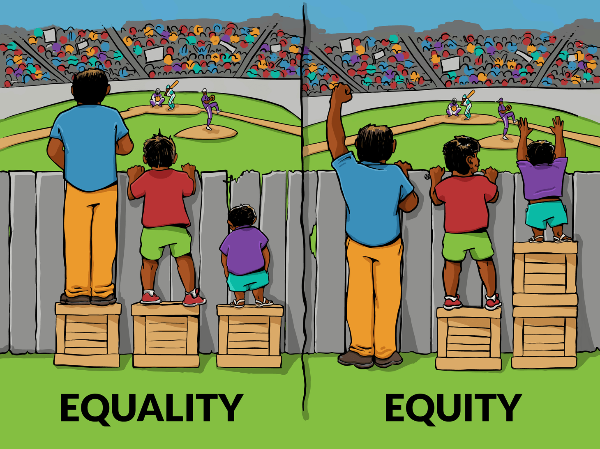
Figure 1: Interaction Institute for Social Change (Artist: Angus Maguire)

Conclusion

Diverse cultural, material and systemic factors influence the extent to which practice in health and social care services is person-centred. The aim here is not to address all of these factors. Rather, the review has sought to distil core shared principles and distinctions between a limited range of person-centred approaches. In large part, the review responds to a concern among practitioners about the confusion generated through multiple similar initiatives. This is particularly relevant in the current context of health and social care integration and in light of increasing pressures on services due to demographic changes and resource constraints.
A key finding of our review is that apparent distinctions between sectors and approaches are perhaps less prevalent than divergences within approaches. A further key finding is that two main drivers influence how approaches are implemented, which can be broadly defined as the relational versus the managerial. Bringing these two findings together, in each approach there is a range of perspectives reflecting those drivers, presenting real tensions and barriers to achieving the identified core shared principles.
Contradictory trends are particularly evident with regard to how these drivers manifest in understandings of equity and seemingly intractable inequalities. All approaches use language claiming to put the person at the centre. There is however an implicit assumption in managerialist thinking that inequalities can be tackled through standardisation of provision and its measurement through performance management regimes.
In contrast, a relationship-based understanding means engaging with the person in the context of material and lived experiences, which might mean a departure from focusing solely on clinical treatments and traditional services. Attentiveness to the person’s whole life requires an understanding of the social determinants known to correspond closely to persistent health inequalities.
The World Health Organization lists the following determinants: stress, early life, social exclusion, work, unemployment, social support, addiction, food and transport. These relate to health outcomes, which tend to cluster together. They have both policy and practice implications. The WHO has identified two broad areas of social determinants of health that need to be addressed. The first area is daily living conditions, including physical environments, fair employment and decent work, social protection across the lifespan and access to health care. The second area is distribution of power, money and resources, including equity in health programmes.
There remains a clear need to measure, monitor and track outputs and outcomes in order to plan and manage services effectively. However, there are limitations to what is currently measured and therefore what is deemed to count. All of the approaches we reviewed advocate at some level the essential relational and holistic practices needed to maximise outcomes for people and address persistent and increasing inequalities. Enabling such practices to flourish requires a re-orientation of performance management frameworks to include relational and holistic factors.

Acknowledgement

Karen Barrie (University of Edinburgh) and Emma Miller (University of Strathclyde) wrote this review in collaboration with a range of contributors, including members of the Personal Outcomes Collaboration. We are very grateful for their contributions.



Scottish Social Services Council
Compass House
11 Riverside Drive
Dundee
DD1 4NY
Telephone: 0345 60 30 891/01382 207101
Fax: 01382 207215
Email: enquiries@sssc.uk.com
www.sssc.uk.com
If you would like to request this document in another format please contact the SSSC on 01382 207101.

© Scottish Social Services Council 2018

Personal Outcomes and Person-Centred Approaches (POPA) graphic was developed collaboratively at an event in 2017 involving people using services, unpaid carers and care professionals working across health, social care and the third sector, captured and digitalised by graphic artist Julie Barclay.
http://charterforhealthcarevalues.org/

