
What to do following changes to your PCs
Managing Static Routes for the NHS SWAN Connection
Adding Static Routes for new PCs and PCs that have been updated.
If you add a new PC to your network or update a PC, you will have to add a new static route.
You will need to add 2 static routes to all your PCs and server to access NHS Services. A static route is a signpost that points your practice equipment to the NHS/ SWAN network and allows you to connect to all the services that you use. To configure a static route, click on the Windows Start button  and type CMD. There is no need to click in a field first. Just type the letters. The following pop up will be displayed. Right click on Command Prompt | Run as administrator
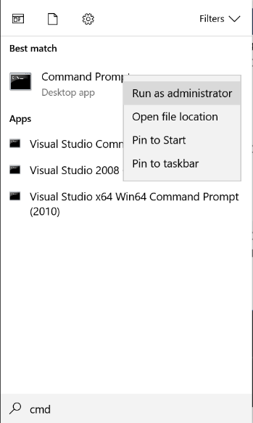
Right click on Command Prompt and select Run as administrator
Alternatively, click on Start and scroll down to Windows System and select Command Prompt as shown below:
Right click on Command Prompt |More | Run as administrator
Point to Windows System

You may be presented with a pop- up asking if you want to make changes. If so, click YES The Administrator: Command Prompt window will be displayed as picture below. Type - route print and press Enter on your keyboard.
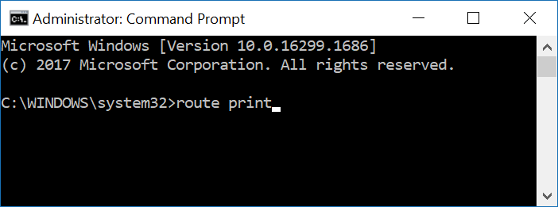
Type route print next to system32> and press Enter on your keyboard

Pictured below is the text that will be displayed after entering route print as described above:
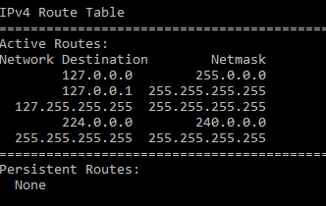

The text should say Persistent Routes: None as displayed above and you will need to enter the 2 static routes required.
NOTE: Please note you may have a route 0.0.0.0, this is for the internet to work so do not remove!
The following uses the IP Address of 192.168.1.8 for the CAT20 address. If your CAT20 has a different IP address, please change accordingly

Your CAT20 IP address is:
(Engineer installing the device to enter IP address of the CAT 20 here)

Click next to Persistent Routes: None as displayed on the previous page -
Type route –p add 10.240.0.0 mask 255.240.0.0 192.168.1.8
Press Enter on your keyboard
Type route –p add 164.134.0.0 mask 255.255.0.0 192.168.1.8
Press Enter on your keyboard
Pictured below is the command prompt with the 2 routes you have added displayed in the text:
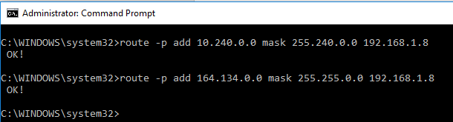

Note:- This is an example and your routes should have Gateway Address of your CAT20 IP Address.
You now need to confirm the routes that you added have been entered correctly.
Type route print
Scroll up to IPv4 Route Table Persistent Routes. The 2 new static routes should be displayed as shown in the box below:
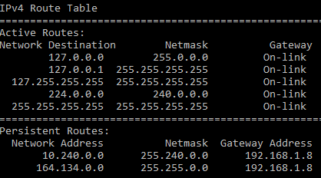
Note:- This is an example and your routes should have Gateway Address of your CAT20 IP Address.
If the 2 static routes are displayed, you can now close the Command Prompt window. You will now be able to connect to all your NHS services.
As an example, picture below is the log in window for eOphthalmic Web Payments. You should now be able to log on from the new PC.


