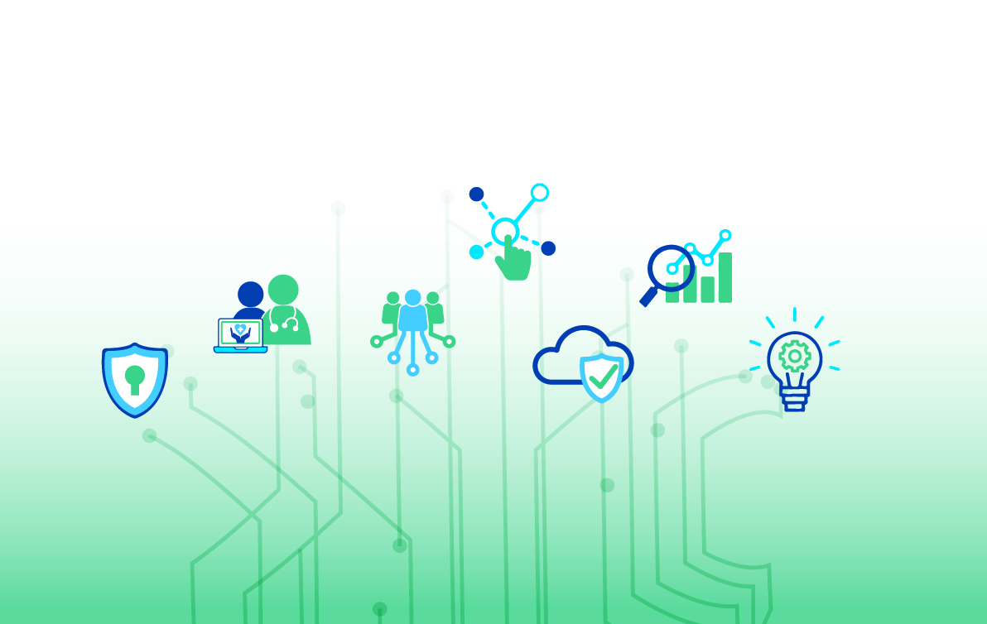
Managing Your CAT 20 Connection to NHS
Optometry Practice Connection

CAT 20
The device you need to connect to NHS is called a CAT 20. The brand of device you have been supplied with is a Fortinet Fortigate 30e. The front of the CAT 20 is pictured below.

The device is connected to your network via the WAN Port on the back of the device and numbered No 3 as in the picture below:

The following lights on your device should be on i.e. green; PWR, STA, WAN – LINK/ACT and SPEED. (The Speed light may be Yellow; this is OK)

Troubleshooting
No Lights Check that the power cable is plugged into the device and the electric power and switched on at the socket.
NO WAN lights – Check where the network cable is plugged into your network. It should be plugged in to the WAN socket, No3 as shown above and the other end in to your WIFI router or network switch.

IP address.
The CAT 20 is given an IP address on your network and is pre-set with your broadband default gateway IP address. If you change your broadband provider or router the IP addresses/Default Gateway may change and the CAT20 will need to be reconfigured. We would advise that you get someone to change the router’s Internal IP Addresses and Default Gateway back to what it was originally set as. This is the quickest option. If we are required to change the CAT20 details, then we will require someone with good PC skills to talk them through changes.

Route and IP DetailsOn each PC that you require to access any of the NHS Services, 2 static routes will be added. See separate guide for checking and adding these.

- Route 164.134.0.0 for eopthalmics.mhs.scot.nhs.uk & www.bo.scot.nhs.uk
- Route 10.240.0.0 for www.scigw.scot.nhs.uk

Check List
Before you follow the steps outlined in the flow chart below. You should ensure that you can connect to the internet from your practice, for example open a web browser and perform a google search.



Cannot Access eOphthalmic Web Payments.
Follow Instructions for rebooting CAT 20
No
Yes
Please ensure that the NHS website you are trying to connect to is available before making any changes to Static Routes. You can do this by calling the service desk on: 0141 282 2100
A user guide to Static Routes will have been given to the practice when the CAT20 was installed.

Can you access eOphthalmic Web Payments on any other PC in the practice?
Follow instructions on Checking / Adding Routes
Can you access other NHS sites?
Yes
No

