
SCI Gateway Installation Guide
Installing SCI Gateway Client
To install the SCI Gateway client open Internet Explorer  on your PC.
Enter the URL for SCI Gateway into the address field www.scigw.scot.nhs.uk/web/login.aspx
Enter URL here and press the enter button on your keyboard.
SCI Gateway log on window will be displayed. Click on the link Client installation:
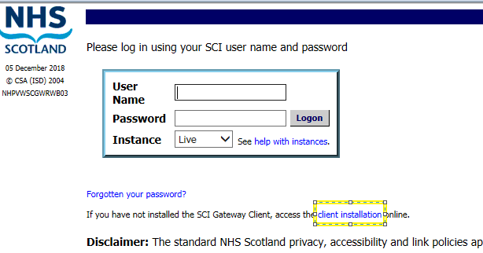
Click on the Client Installation link
The SCI Gateway On-Line Help window will be displayed in a new tab. Scroll down through the text until you find Install: Gateway Client section and click on Full Client install:
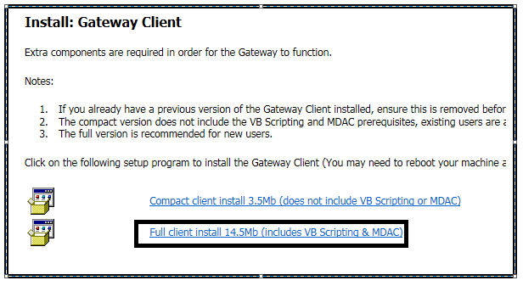
Click on Full Client Install 14.5Mb (includes VB Scripting & MDAC) link
Pictured below is a pop up message at the bottom of the window, displayed after clicking on Full Client Install 14.5Mb (includes VB Scripting & MDAC. Click on Run:

Click on Run

You may be asked if it is ok to make changes to your computer. Click on yes if asked.
The install Shield Wizard will be displayed
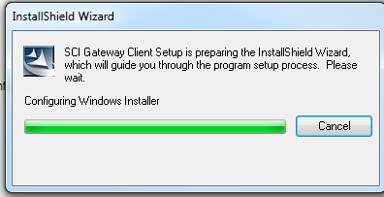

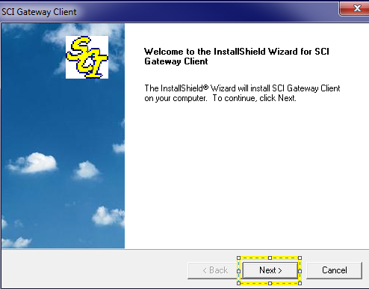
The SCI Gateway client window is displayed click on Next

Pictured below is the SCI Gateway Client window opened with Setup Type displayed after clicking on Next as described on the previous page:
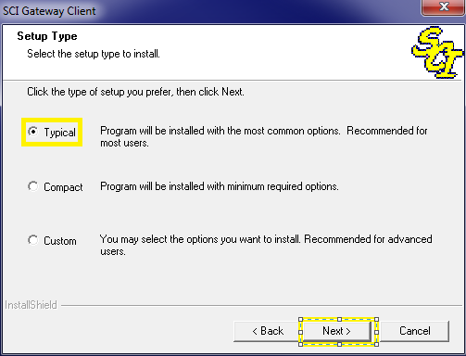
Select the radio button Typical and click on Next

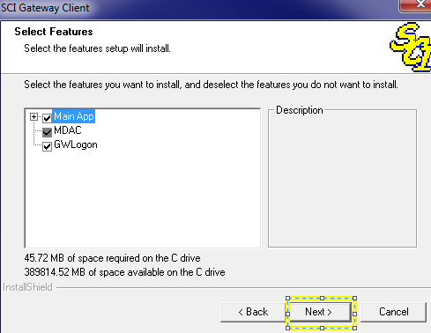
Selecting the settings as shown here are selected and click on Next

Pictured below is the SCI Gateway Client window opened with Start Copying Files displayed after clicking on Next as described on the previous page:
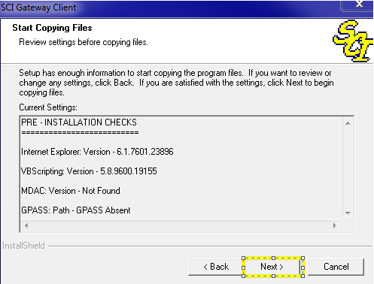
Click on Next

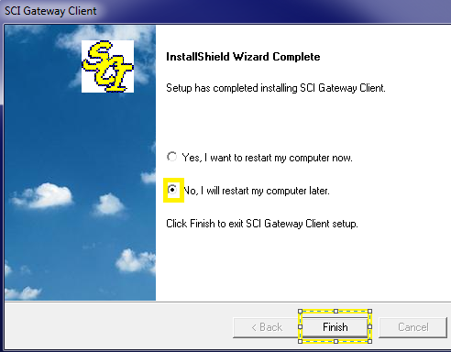
Click on Finish

Internet Explore Settings
You will need to take steps to make changes to Internet Explorer settings that would prevent SCI Gateway functioning as it should. Click on Internet Explorer Tools on the menu bar or press Alt X on your keyboard or click on Tools icon
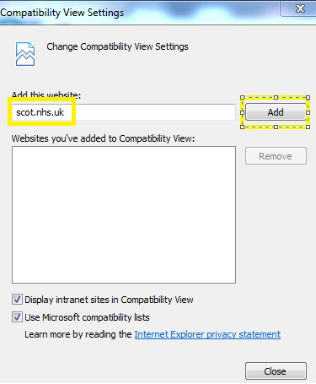
Enter scot.nhs.uk into the field and click on Add and Close
Click on Compatibility View settings

Pop Up Blocker
Open Internet Explorer Tools menu as described on the previous page. Click on Pop-up Blocker:
Click on Pop-up Blocker |Pop-up Blocker settings

Pictured below is the Po-up Blocker Settings window displayed after selecting the option as described on the previous page:
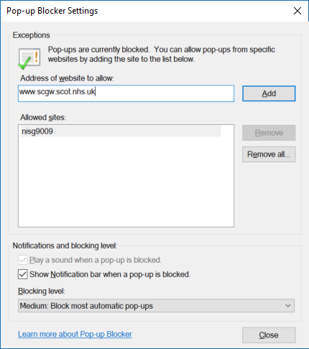
Click on Close

Enter SCI Gateway URL and click on Add
Click on Add

Logging on to SCI Gateway
After you clicked on Finish as described on the page 5 an icon was deployed to your desktop. You will now be able to log on to SCI Gateway. Click on the icon 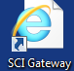. A window will be displayed with the icons as pictured below. To access SCI Gateway, click on the NHS icon:

Click on NHS Scotland

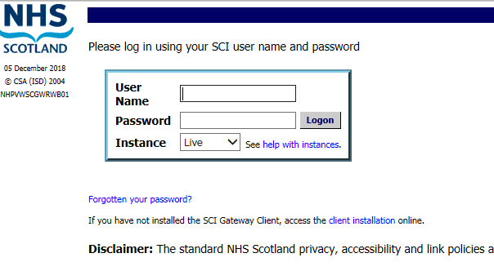
Enter a username and password to log on to SCI Gateway

